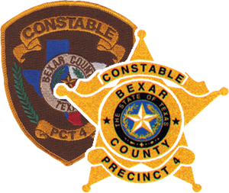 | Bexar County Constable’s Office PCT #4  Course Title: Racial Profiling TCOLE #3256  Instructor: Deputy Chief George D. Little  LOCATION: 2711 S.E. Loop 410 So. DATE:
Please rate the overall quality of this course and/or presentation | Unacceptable Poor Satisfactory Good Excellent  All ratings/scores of a 1 or 2 require written detail justification on the reverse side of this form. (Please be constructive, specific & professional)
Instructor Appearance  Instructor presented lesson clearly and logically  Instructor displayed general knowledge of lesson delivered  Instructor was easy to understand  Instructor answered all question(s) thoroughly  Instructor covered all learning objectives thoroughly  Lesson goals were achieved  Instructor’s demeanor was Professional  Participant handout with sources & references were helpful  Were the knowledge & skills  taught helpful to you  Classroom facilities | 1 2 3 4 5  1 2 3 4 5  1 2 3 4 5  1 2 3 4 5  1 2 3 4 5  1 2 3 4 5  1 2 3 4 5  1 2 3 4 5  1 2 3 4 5  1 2 3 4 5  1 2 3 4 5

Did the lesson PowerPoint help you to understand and visualize learning objectives?
What was the most valuable learning objective to you? Why?

Did you gain knowledge and/or skills from this course that will enhance your job performance? Please Explain:

Suggestions to improve (Comments): Feel free to write on the back your comments help us improve course quality
(Rev:09-03-14)

